**Conversation Guide: Digital Health Modernization Discovery Research**

**Bold text identify the moderator’s questions.**

*Text in italics are Jen’s observations and interpretations of the participant.*

[Text in brackets are interpretations in participants’ direct quote.]

**Background (5 minutes)**

To get started, I’d like to get a little background information about you, and your experience with the VA.

1. **Can you tell me a little bit about yourself?**

I am Ken and I was born and raised in Kentucky.

I joined the Marine Corps right after high school served for 30 years. Been retired since 2014.

I started a job after I retired but my body and brain told me that wouldn’t work so I have been retired since October of 2015 and have been plugging along since.

I had a job as an operational supervisor at the Gap distribution center. I made it to the top in the military then at the end the more meetings and the more you get stuck at the desk. I like working with people so instead of taking executive jobs I took a job with the Gap working with 80 people in my direct supervision. So I liked that part of it.

I could have made a few more dollars somewhere else but I would rather work with people.

1. **When did you leave the Marines?**

My last official day was November 30, 2014 but I was on terminal leave from August to November.

1. **What sorts of things do you receive from the VA?**

They have done some extensive PTSD, anger management counseling.

I did a little alcohol rehabilitation, although that wasn’t a necessary thing. I asked for information to help overall health and then next thing I know I was in a 12 week substance abuse situation with a lot of hardcore addicts and I wondered why I was there. I finished it and learned a few things besides what crackheads talk about. They blamed the system for their problems, and that aggravated me to no end. But I signed up for a program so I finished it.

But they’ve done a lot. The VA rated me at 100 percent disabled, so I’m pretty beat up. I am not good at showing it, because I never could when I was on active duty. So I have that problem at times, at remembering just how beat up I am. I’ve never been really good at listening to pain even with it being quite debilitating.

I have a lot of spine issues. Pretty much every joint is beat up. There’s not many parts on my body that work real well.

But I have a daughter that has been in a wheelchair her entire life so who am I to complaint about a few aches and pains.

If I wake up and something don’t hurt I look for a pulse.

**You mentioned a daughter. Do claim her as a dependent at the VA?**

No, she is a stepdaughter and 48 years old living in California. Been a functioning quadriplegic her whole life.

I know quite a few Marines that have lost limbs in combat so I have a lot of reasons not to sit around and complain. As I’ve seen and heard a lot of my veteran peers do.

I have never done that but anyway I guess I am too stubborn.

But it does, it takes my lunch money every day but I try not to let it get it all.

**Primary care through VA**:

I do. My doctor primary care doctor at the clinic, I see her about 2 times a year unless I have an issue. I can see her as much as I need.

I have follow ups, they take care of my meds as well.

I go to see someone about mental health each quarter for checkup as well.

Right now they have an intern rotation so it is like hot potato. I may see someone once or twice then have to start over with someone new. They can read notes but can’t carry on a conversation because they don’t know a damn thing about me really. That’s disappointing but it is what it is.

**What’s that experience with change of providers:**

It is a check in the box for the VA is all it really is.

I go in there and we talk about making sure my meds, I have enough refills, and if there’s anything crazy going on in my life, or crazier going on. They always want to know if I’m going to kill myself, and all that good stuff going on.

But, yeah, it’s more of a check in the box for them.

I had one for a year, he was a good listener and responder, and we had a pretty good relationship.

But all of the good ones go somewhere else and I am stuck with whoever the next person is.

**Check in the box feeling is that for mental health care primarily:**

More so for mental health. It bothers me. I still have issues and nightmares. Thing I wish I hadn’t seen, I have hard times in crowds.

I’ve been told I am in introvert but I like talking to people just not always good at it. Because I am worried about them doing silly things. Because I’ve seen some people do some stupid things like blow themselves up.

I’ve learned humor is the best medicine. I didn’t know how to laugh before.

I learned life is to short to be too serious all the time, so I try to laugh when I can and I find that helps.

**Outside of the VA do you use any other medical providers:**

Only if they farm me out somewhere.

Which is a good thing. They have the veterans One Choice I think it’s called. I haven’t used it in a while.

If they can’t get me scheduled for several months out they will farm me out to the local doctors. I have had some that are pretty good.

I have a fusion in my back and in my neck. And they weren’t done very well. To say it mildly they really didn’t do a good job.

The neurosurgeon out here in town, one refused to see me after seeing the scans. The other one I went to see but pretty much told me I was screwed. He was blunt and I appreciated his candor. He said I wouldn’t want to touch that unless I had to because there was an 80% chance I wouldn’t walk again so I have to suck it up. So I just say its beats the hell out of not walking.

**For the Veterans One Choice program is that what you’ve used primarily for specialists:**

Usually it is.

They sent me out for acupuncture for a while, it didn’t do anything but it was worth a try.

Most of my issues are neurological issues, and spinal issues, so they farm me out when they can’t get to me or there’s a specialist.

They also come in to help after I go to the ER, they usually roll in, so they help with the Tricare insurance.

It’s actually a pretty good program, and they have taken good care of me.

**You mentioned you have Tricare as well:**

Yes, but VA is my primary. Any thing falls back Tricare rolls in.

1. **Any other dependents you claim with the VA:**

Just my wife. Married 31 years, for stupid reason. I can’t imagine. I am incredibly lucky and incredibly blessed but don’t know what she sees in me.

**4.a. Does she receive any VA benefits?**

Just me.

**What about Tricare:**

She is primary Medicare I guess.

1. **Do you manage any of your VA benefits online?**

Oh yeah. Everything I do is on myhealthevet.

Primarily my meds and secure communications, refills, things of that nature.

I don’t use it a whole lot.

I sometimes check the appointments but my calendar is good.

I don’t use a lot of the other features.

Primarily it is the communications and prescriptions.

**Other features that come to mind that you don’t use:**

There’s something on there about my medical records, my files, I haven’t found anything there before.

When I retired and put in all of my medical records, I had six volumes, six inches thick, because I have had a few surgeries and more broken parts. More then I like to admit.

When I turned that in, to do my assessment, Salt Lake City doesn’t talk to any other VA. So the VA here doesn’t communicate with the VA in Salt Lake City, so they had no records of what was wrong with me.

So then I had to bring in a copy of my records to this VA. They still haven’t scanned them all in there. I figured at this point there’s enough there now.

I still can’t see them on myhealthevet. You’re supposed to be able to go on there and see my medical records but I can’t see them.

**What shows up instead:**

What I have done to date. If I had appointment last month that may be in there but its not all the meat and potatoes of what we talked about.

It’s usually just my blood pressure or weight, but not all the important parts we talk about and it is a little disconcerting.

I tell her - hey this is bothering me - but I don’t see it in there.

**So you’re not seeing notes:**

I see some of them but not all.

It makes me wonder if its being written down or is not a concern.

**Besides My HealtheVet do you do anything online for your disability:**

No. I have put in for Social Security disability claim a couple times and have been denied.

Although the occupational therapist testifying for the government told the judge that I was pretty beat up and there was no jobs the therapist listing that I could actually do well for any amount of time.

Their whole goal is to deny you and save the state some money.

They said I could go sit and sort mail. Thats what they said a couple times.

I was contemplating putting in one more claim because I was told when you are 54.5 they will treat you like you are 55, which changes a lot of the parameters. But I am at the point where it’s just not worth it.

**VA disability, anything you have to do on a regular basis for that benefit:**

Not really. Once they assess you at 100% that’s pretty much it.

I have check ups often and re-certify that I am pretty beat up, but I haven’t had to do anything else.

**Do checkups to see how you are doing how are you notified:**

They are scheduled before I leave the office.

I tend to schedule then 6 months out and if my schedule doesn’t jibe up anytime I can call or secure message them.

The consult today is from an issue. Usually takes some time. I will never call today and have an appointment tomorrow it may be a month or two maybe out. Depending on the severity.

And I get it. There are probably guys out there a lot worse off than I am.

**Other websites outside of My HealtheVet for the VA:**

Ebenefits, I go on their occasionally. Not very often to verify something to ensure that the program is being worked. I have used that as well.

**Is that for your disability or are there other benefits your check on:**

Mostly other benefits.

What’s in the system for my disability is already there. Nothing pops up like this is what’s going on.

1. **Do you use any mobile apps to manage your health or mental health?**

Not really. Not really an app person.

I have went on myhealthevet on my phone but that just the same way I would do it on my computer.

I can’t think of very many apps I use.

**Mental model of health at the VA (20 minutes)**

Now I’d like to hear about your experience transitioning from the military to the VA. **(10 minutes)**

1. **How did you learn about the health care available to you through the VA, and what was the process of applying for and accessing those benefits?**

It starts before you leave active duty. They have DAV [Disabled American Veterans] there on base. Or you can go to VFW or American Legion.

But the DAV was very helpful, they are retired people, it’s all volunteer and it is incredible.

I actually helped my 96 year old father get into the VA last year. He had never gone to the VA and I got him enrolled in there he was a WWII vet.

I went through the DAV and gave them all my paperwork, they submitted it all for me, and they did a great job. It was all pretty seamless.

**Your father never got anything from the VA:**

Not a thing. That is typical of that generation they aren’t like there’s a bone sticking out they would wrap it up and carry on.

We had a few hiccups, but he’s got some pretty good care, and we are still in the process of finalizing his disability claim.

They found several issues with him as well. They came back for 10 percent for PTSD, they verified that by an online interview.

Since then he’s had x-rays of his back, hips and knees. He’s had hearing tests and all that good stuff. They’ve already given him hearing aids.

They have to verify his claims so it’s going through the process and I think he will be like 30 percent. So that’s pretty nice.

**What motivated you get him enrolled:**

I guess I finally caught him in a weak moment, he always said there were people worse off. He’s just of that generation.

Mom is terribly upset because she has a little dementia and she is scared to death she will lose her primary care physician from his work insurance where he retired from. But that’s just how she is.

He is happy to see a check in the mail now.

**So you learned about the VA before you officially retired from the Marines:**

Yes, and I have helped countless Marines who retired or were transitioning out through the process. I had to learn about everything about retirement way before my retirement so I could be helpful for my guys.

I didn’t know everything there was to know. But I knew who to point people toward and how to get started, it was later when I got better at it.

1. **When did you personally applied for VA disability and health care:**

It was at least 6 months before I retired so somewhere in the February timeframe of 2014.

1. **Do you remember what the process?**

When I was on active duty I had access to all hospitals and clinics on base.

For some it takes years for others claims take forever. That is primarily because they tend to wait to submit.

I knew we could submit six months prior. And we got top of the pile privileges, or at least we were looked at quicker then those that did not do it early.

I found out what my disability rating within a month or two of retiring.

When I got here I got to the VA and got enrolled and set me up and monitored me until I got my disability rating and pretty much things changed.

Now they take care of everything.

**How long until your disability:**

I think it was a month or two. It took 7 months from when I submitted until I actually found out. But like a month or two after I retired.

**You said everything changed after that:**

Yes, as soon as they designate you 100 percent they pretty much take care of everything.

There are a lot of veterans that don’t get what I get. Like dental.

I think you have to be over at least 30 percent to get any kind of real care.

Having 100 percent opens a lot of doors.

1. **When it comes to Tricare/Medicare do you manage that online:**

I don’t. I don’t manage much of my own online because there isn’t a lot besides sending a message or refilling prescriptions.

I am a smart guy, I have a master degree, but my brains been a bit scrambled I guess. My memory isn’t as good as it was. I don’t have a good focus; I can’t focus for a long time period.

1. **How would you explain a “disability rating” to a new Veteran?**

As I have told everyone that I can tell, we are not good at saying I am broken. That was part of my problem is waiting until something that was sticking out before I said ouch. And a lot of us are that way.

So I tell them to document any problem they’ve ever had and put in a claim. A lot of people at my level didn’t want to because they didn’t want the stigma of being broken. But I encourage them to make sure everything is documented, and turn in their medical records.

Tell them to let the DAV to assist with the application and go through the process.

Go to the appointments and get checked and poked and prodded.

It is humbling experience because they identify just how broken you are. When I finished my retirement physical I was humbled. They took 48 x-rays within 2 hours. I never got off the table unless it was to change positions. They were checking every little thing, but they put me through the paces. They reminded me just how much it hurt and showed me how much I couldn’t do.

One of things I always remember I went into the psychologist. I went in as a tough Sergeant Marine bravado, I’m tough and I don’t have time for this. Within 30 minutes she had me in a puddle, she broke me down. And that was really humbling because I sought a little mental health assistance a year or two before I retired because I had realized issues that none of us really wanted to acknowledge that.

I would tell them to go through the process and be honest. Its not that integrity is a problem of ours, it is being honest about what is wrong with us. That’s kind of contradictory. We’re honest except when it comes to ourselves.

That is one of the things I would tell everyone. Be honest, let the chips fall where they may, and it is what it is.

**What’s the advantage of applying for disability:**

Well, obviously the financial part and medical care part.

Anything done away from the VA is expensive. Insurance is expensive. It’s probably going to get worse.

You just really don’t know and it is a satisfying peace of mind that I wonder need to worry about what is going on in the private sector for insurance.

And not being able to work that little bit of extra income helps, because I can’t work and my wife doesn’t work either. So we live on a pretty tight budget but with my pension and disability we do okay.

**Do you share what disability rating means in terms of their healthcare when Marines retire:**

Absolutely, I don’t know exactly what each percentage means because I don’t remember.

I tell them whatever percent they get means something to them in the long run. Not just care but financial. Making a few bucks.

I think my dad getting a check for $156 and that just made him giddy because he is really tight but has more money then he ever needs because he grew up during the depression. So it’s a few bucks in your pocket.

I always remind them that just because you think you’re not broke now doesn’t mean you’re not going to be. Which means anything you have in the system they will help take care of.

And the other bottom line is we don’t get any better. I laugh about it, but sometimes it really makes me really upset but I cant do anything about it.

The things that are wrong with us now. I have been told I will be in a wheelchair before I am 60 just because my parts are failing and they are only going to get worse. They can’t fix me unless they put me in a position where I can’t walk.

So I try to make them understand it is worth going through the process.

There are a lot of vets who hate the VA, mainly the Vietnam veterans, because it sucked back then. Even within the last 3 or 4 years it’s been pitiful. People are dying waiting for appointments.

So its better now. Luckily the current administration has been fantastic for veterans.

**What has changed the last few years:**

The opinion of our worth. The focus of doing what’s right for veterans. Putting the right people in the right places and then getting rid of the dead beats.

I worked with the State Department in my career. I have learned it’s really hard to get rid of people. The civilian contractors are really hard to fire.

That was part of the problem with the VA. You had people working there for however many years, disgruntled, pissed-off at the world and didn’t give a damn if they helped you or not. And that doesn’t do you any good if someone is dependent on you for their health. And they kind of lorded that over you. You need me so you better be nice to me kind of thing. It makes me what to choke them out but you can’t do that. I’m here for help and them sitting on that desk. Having sat on that side of the desk meant give everything I’ve got to help you.

Being able to fire people and getting the right doctors and using Veterans One Source to allow us to get help away from the VA when needed made a huge difference and opened a lot of avenues up for us.

1. **When it comes to your health care, what is the most important thing you need from the VA?**

I would say meds but I don’t like taking them

The personal care is important.

The idea of knowing it is there if needed is huge.

I don’t a lot of attention because I don’t whine much. I’m not a squeaky wheel. I figure there are vets out there much worse than I am.

I guess it would have to be prescriptions. I don’t take a lot of them. I have waved off most high opiate pain killers they want me to take. I don’t want to take them. They make me feel worse. I try to find a nature substitute if I can.

Now I’d like to ask you how you manage information and tasks related to your health care. For each one, talk me through the steps you’d take. If there is something that you go online to complete, I may ask you to share your screen so I can see what you would do. **(10 minutes)**

**Tasks** Moderator should prompt about device usage if participant mentions digital tools or resources.

* **How would you reach out to your VA care team if you had a question?**

I would go on myhealthevet and do the secure messaging.

*Participant open bookmarks on MS Edge on their laptop/desktop, finds My HealtheVet and clicks to open the page.*

* **You had My HealtheVet bookmarked**:

Absolutely. I couldn’t begin to remember all of this stuff.

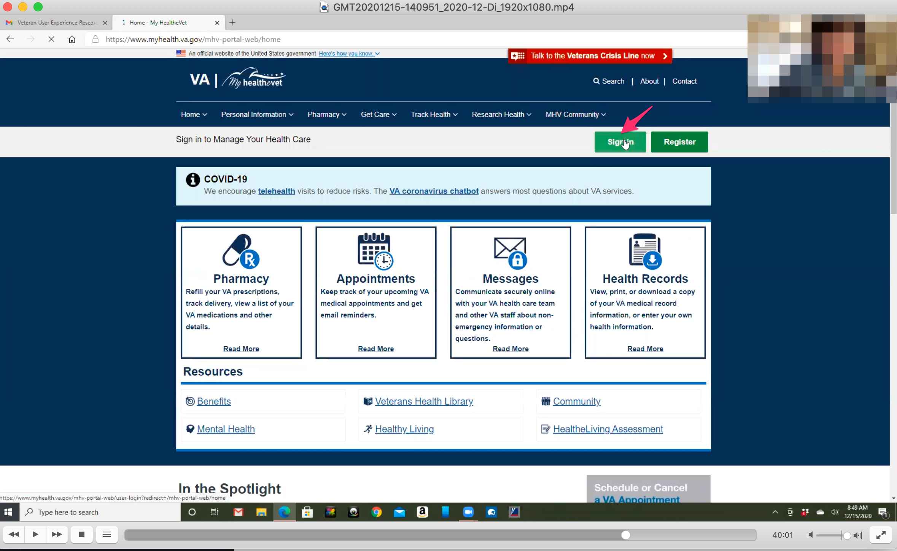

*Participant clicks on green “Sign in” button in upper right of home page.*

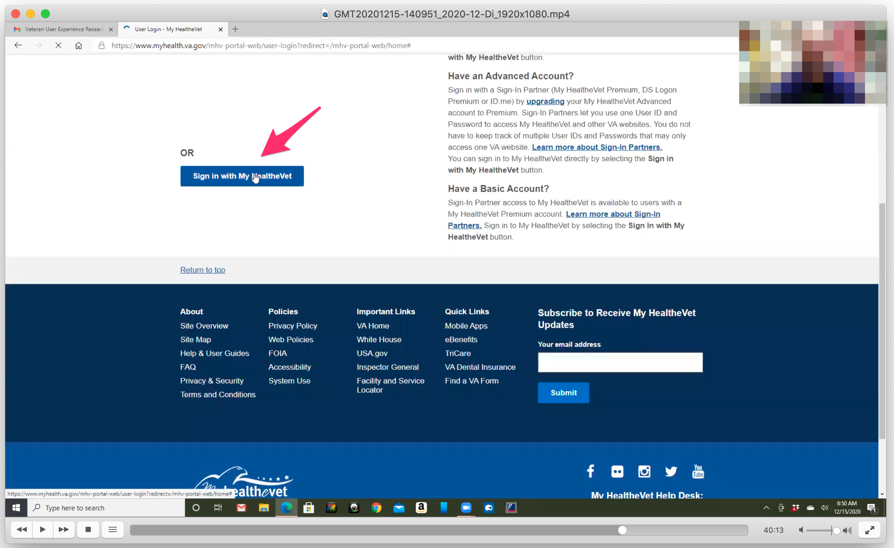

*Participant clicks on “Sign in with My HealtheVet” button. Doesn’t wait long enough for other sign in options to load.*

I would come here and go to inbox.

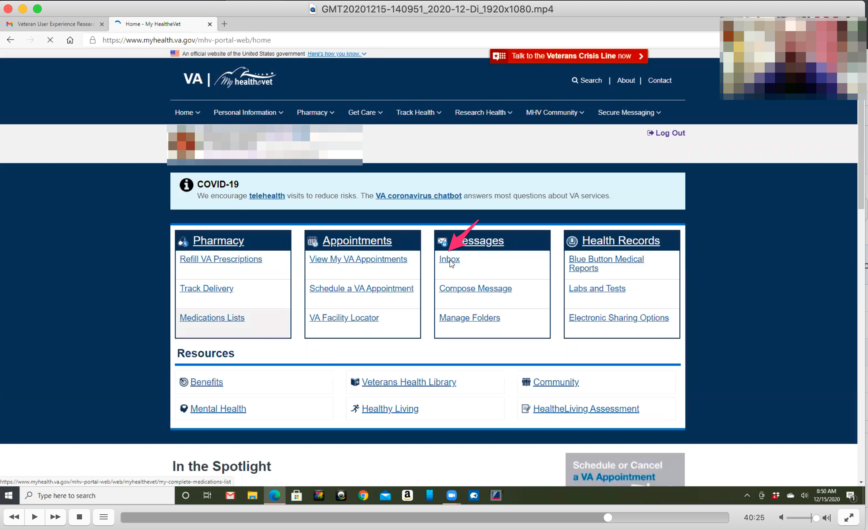

*Participant clicks on “Inbox” link under “Messages” box on home page.*

Then that’s where I compose a message and go through the process.

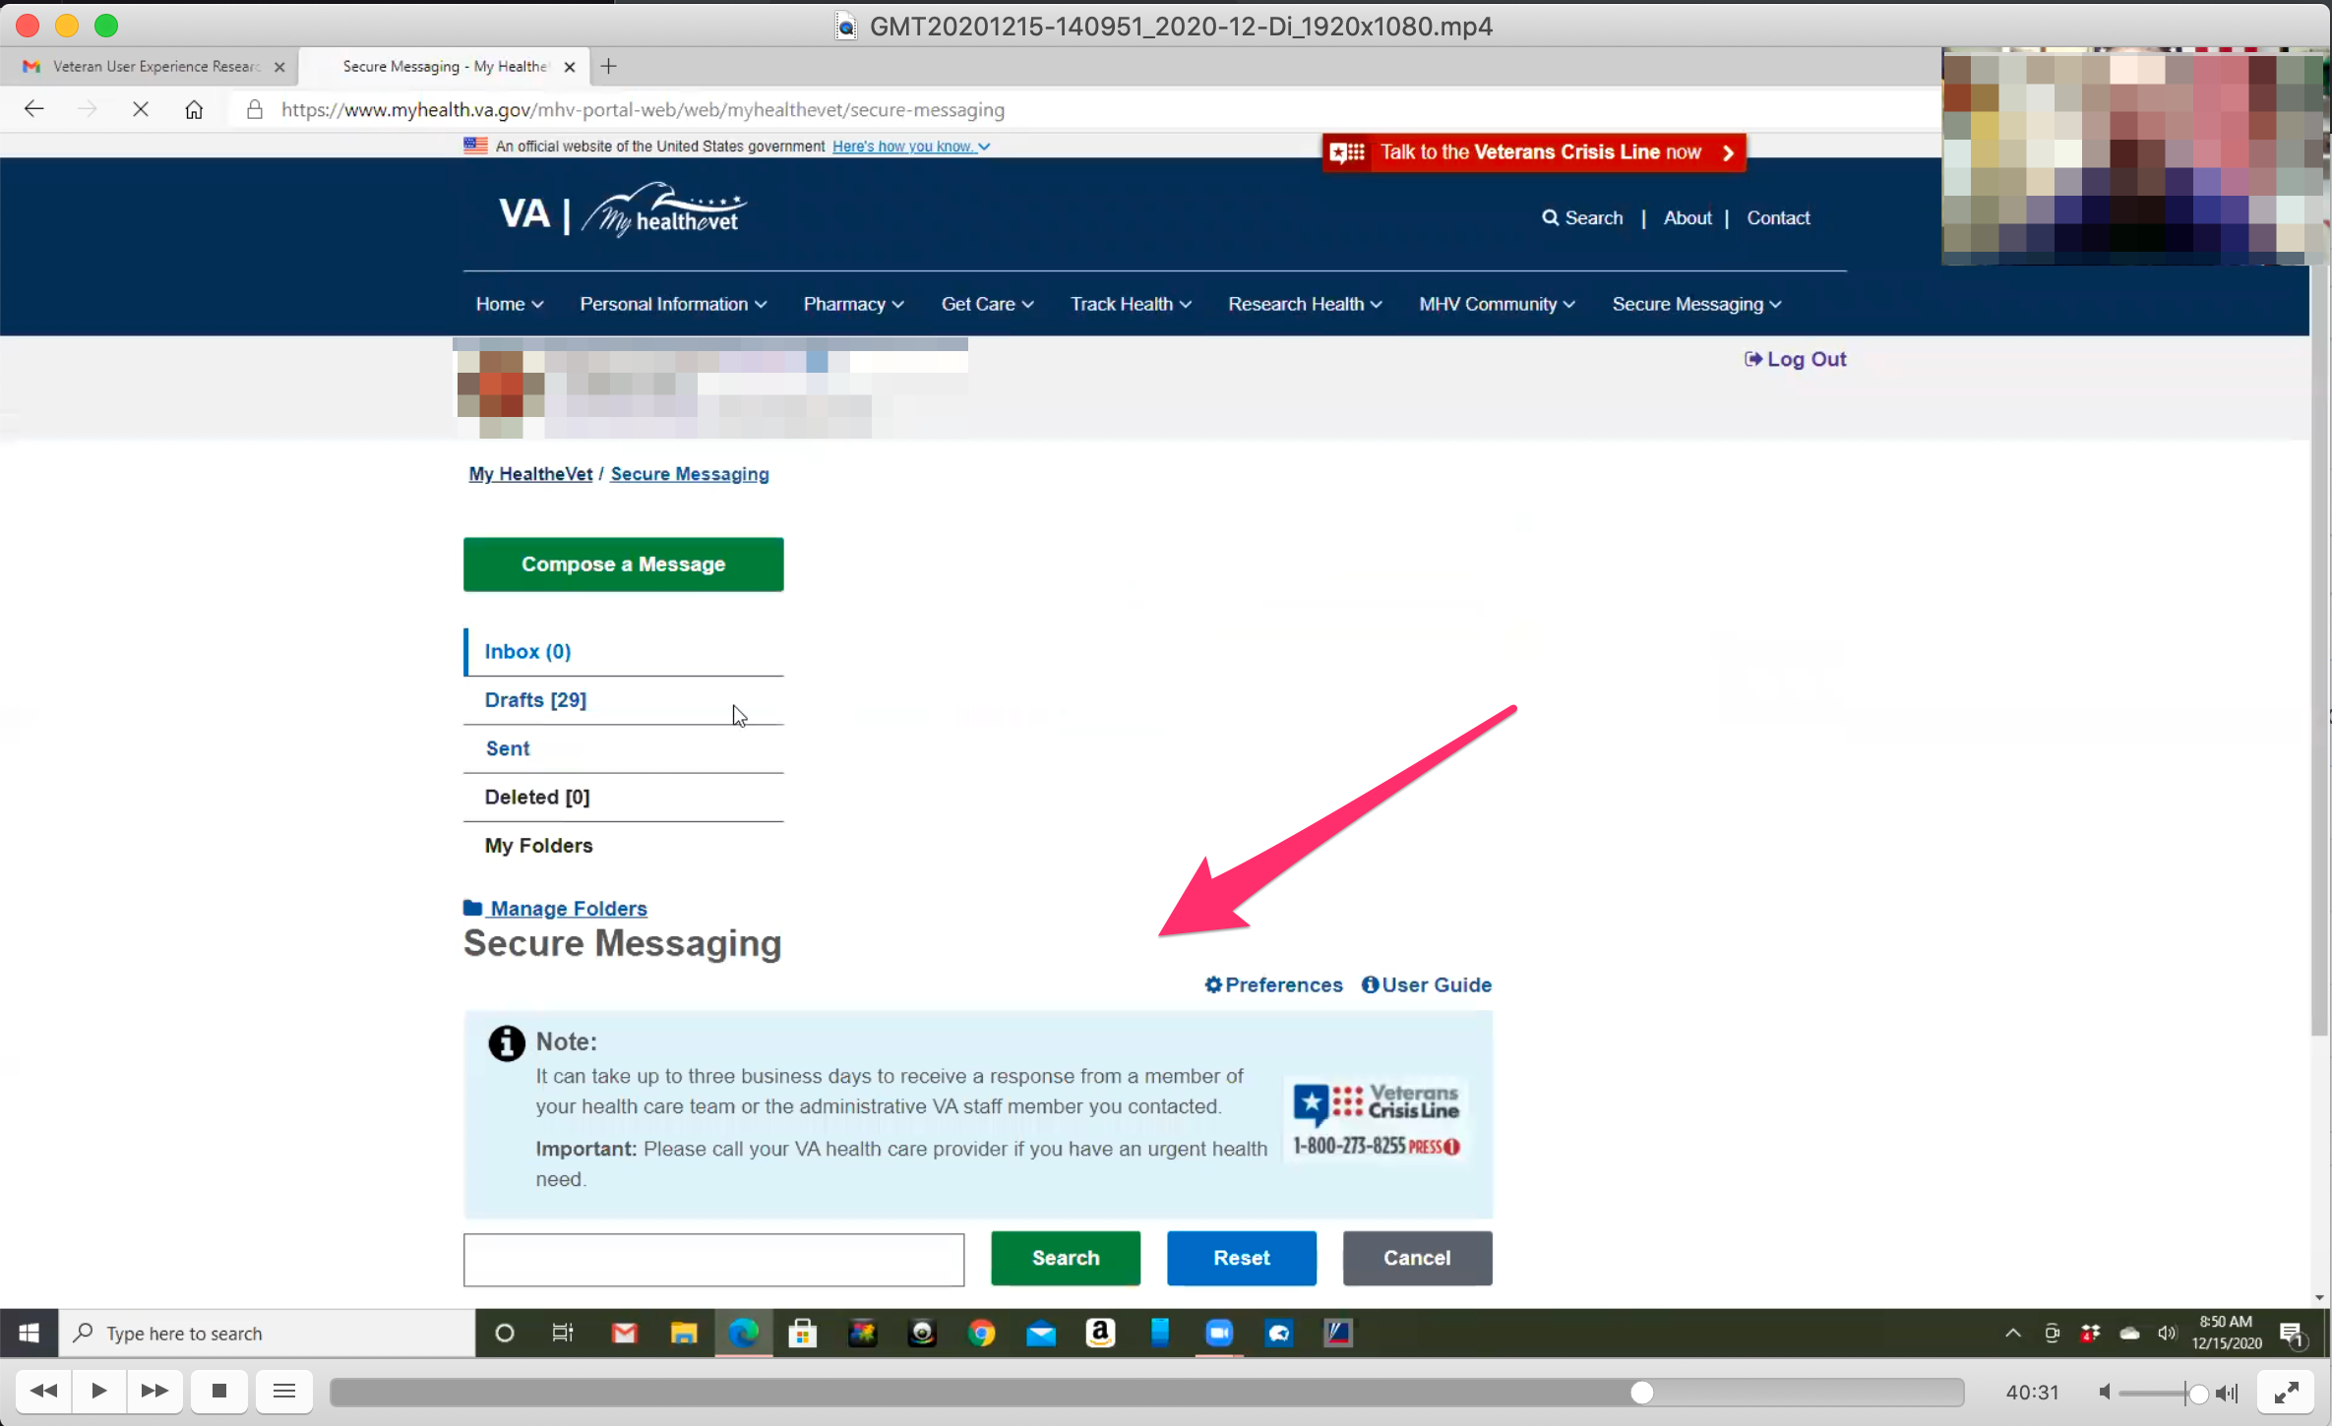

*Main content of page seems to initially load at mobile breakpoint. Shifts after a few seconds. Participant does not comment on layout shift.*

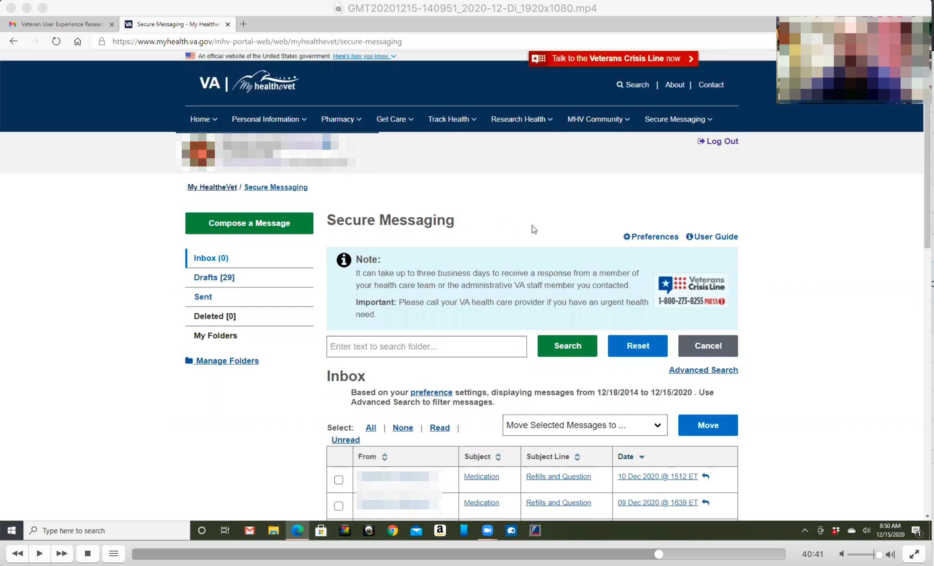

*Participant’s Secure Message page.*

* **You use this frequently?**

Sometimes.

I might go 5-6 months without using it but this month I have had 5 conversations primarily for refills. Through October and now I’ve had conversations but I had refill issues they weren’t just understanding my concerns.

Usually [secure messaging] to talk about prescriptions or to talk about issues. This would be my primary go to.

It goes to the nurse first; it is disconcerting at first but I get it. The doctor’s busy. The last few have been direct communications with the doctor.

But they’re good about it. If I put a message in now I will get a response in a few hours from the nurse telling me they are sending it to the doctor or they will get something done.

It is good they let me know they receive it and they’re working on it.

* **How would you refill a prescription you have with the VA?**

I go to the pharmacy tab and click refill prescriptions.

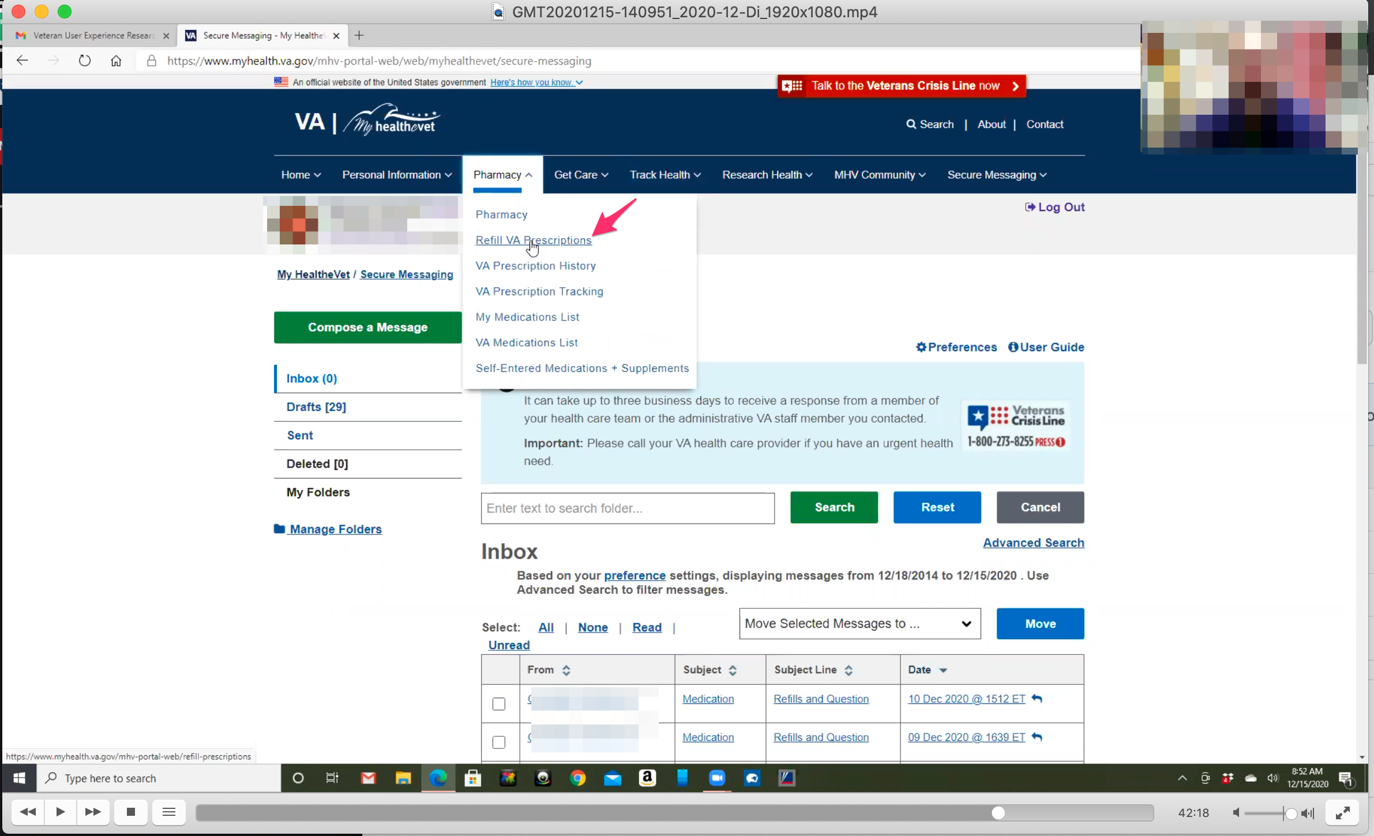

*Participant immediately hovers over “Pharmacy” in main navigation and clicks on “Refill VA Prescriptions” from submenu dropdown.*

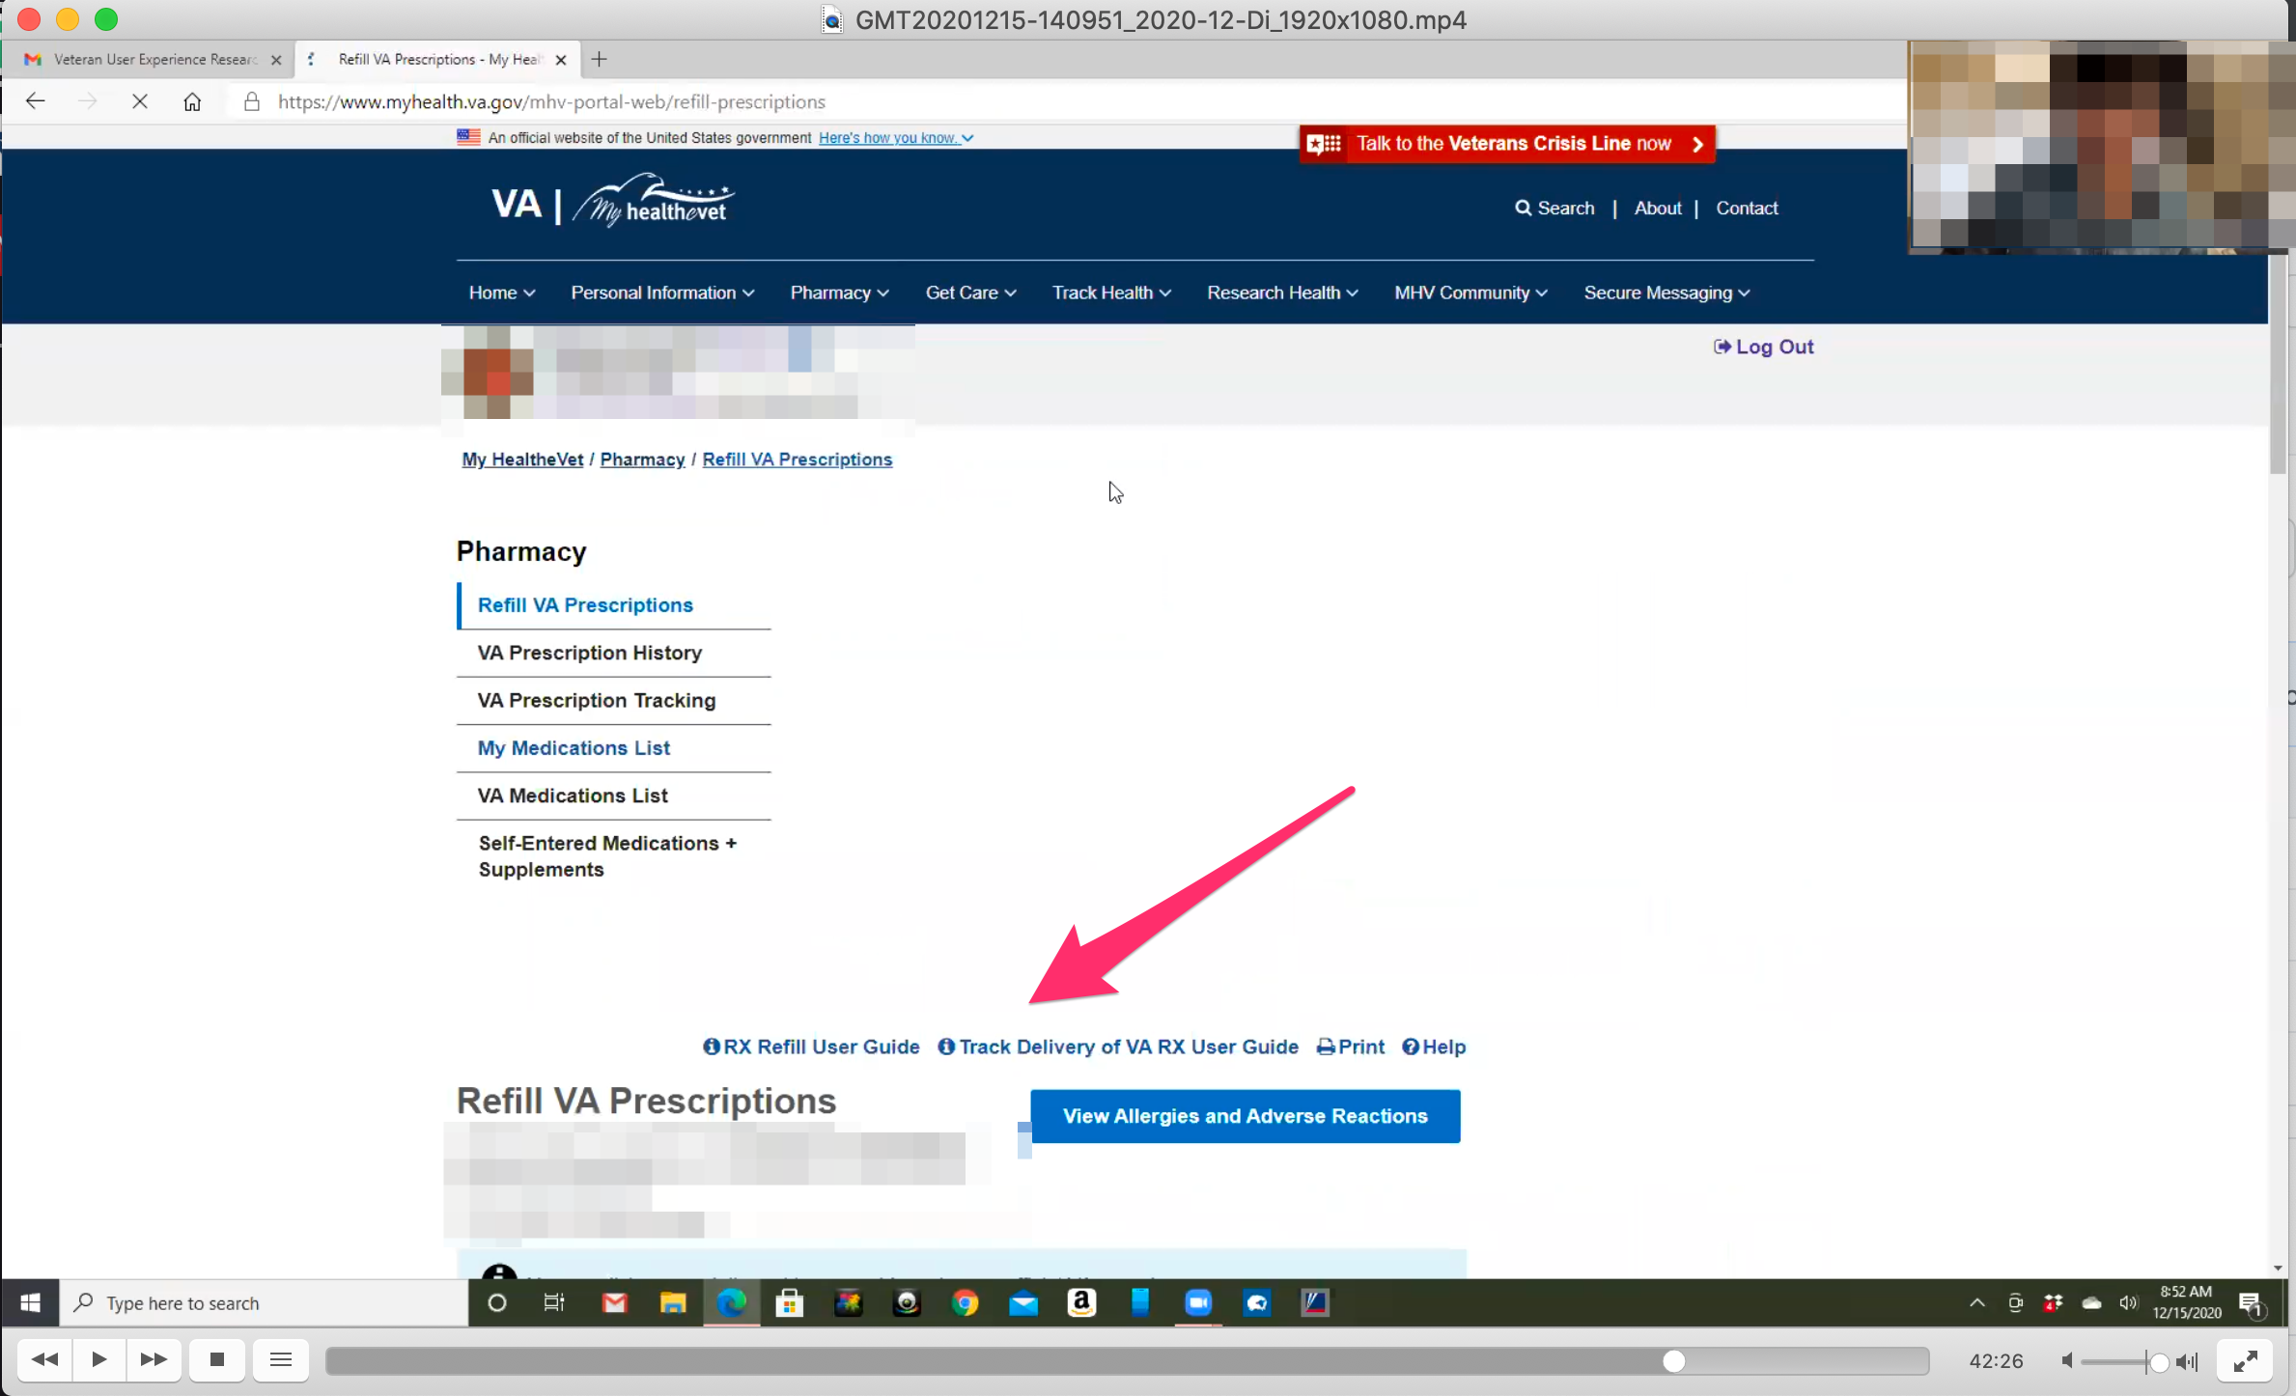

*As with Secure Message page the main content seems to initially load at mobile breakpoint. Shifts after a few seconds. Participant does not comment on layout shift.*

Then once I am here I scroll down and click on something I need to refill.

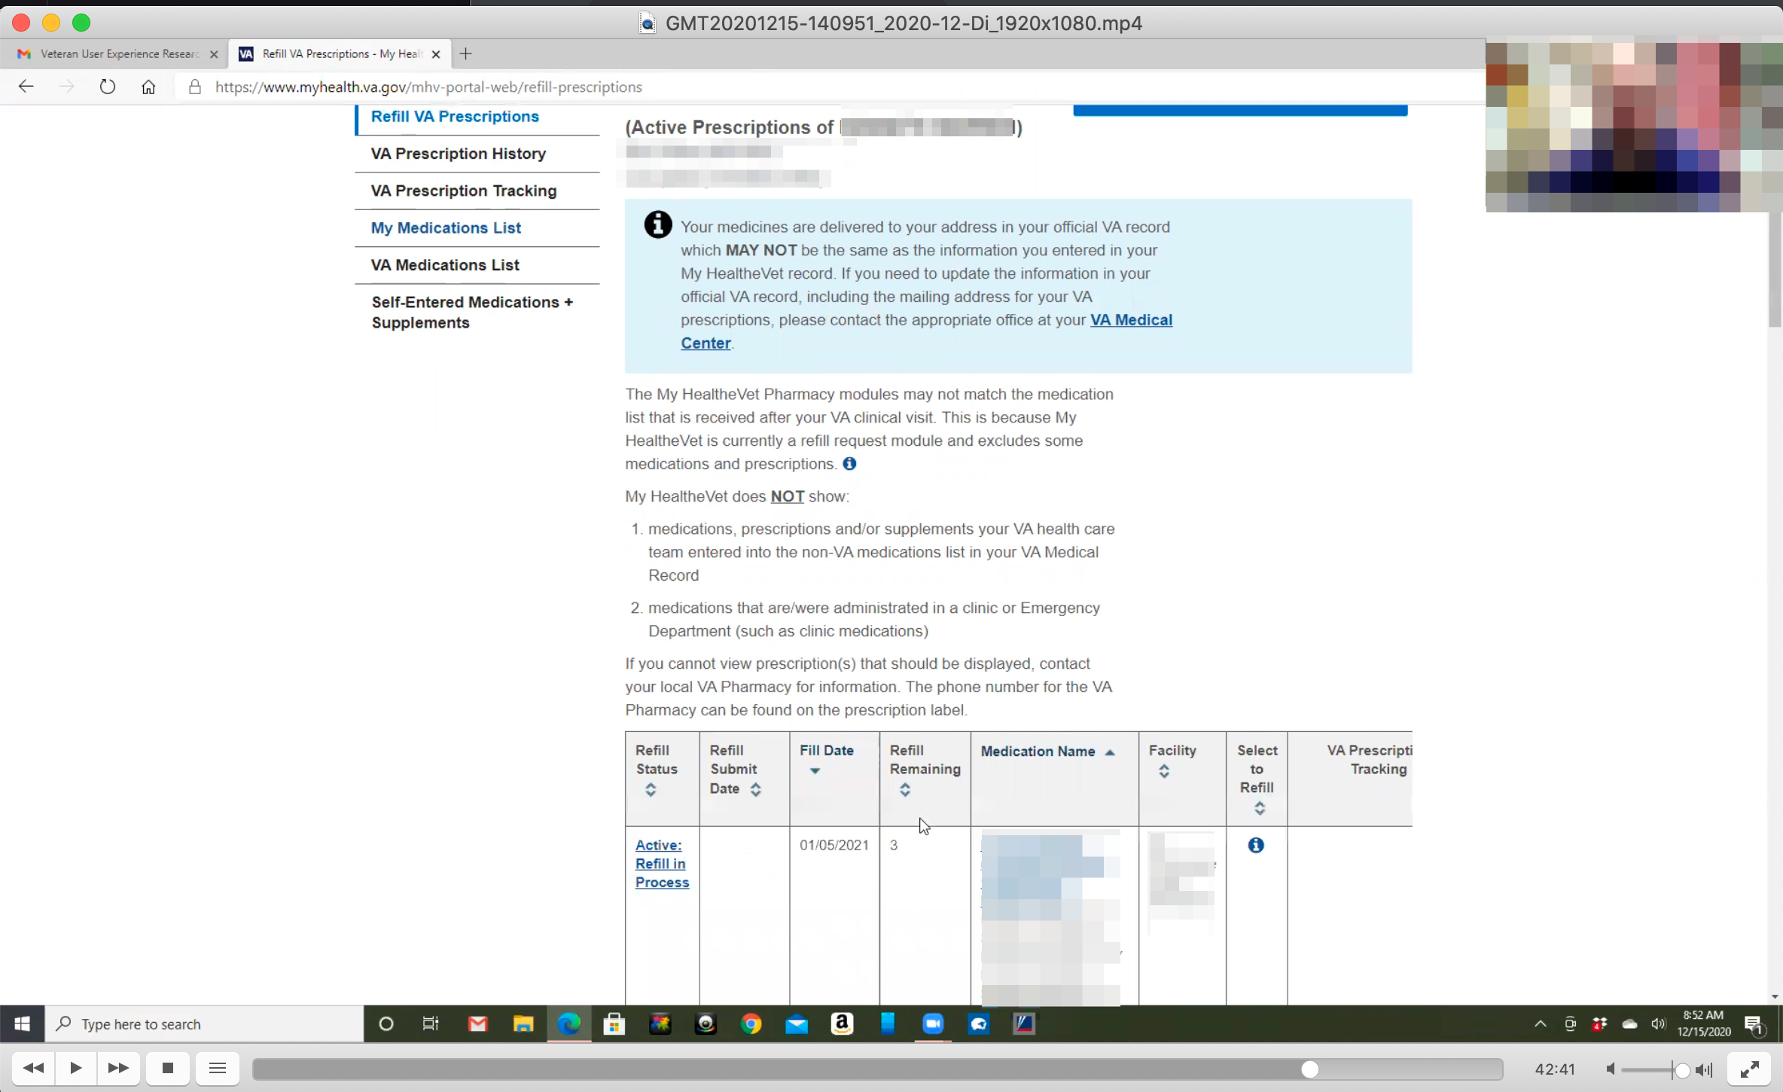

*Participant shows Refill VA Prescriptions page.*

Sometimes it will get to refills reaming at 1 or 0 and I’ll just let them know I am about out.

One issue with my mental health medication is my primary care can’t refill those only mental health can. It sometimes can be difficult because I need to track down the intern and they may or may not remember me so. And may or may not have put in the refills requested at my last appointment. So that’s more difficult but they usually eventually get back to me. Everyone does pretty good I guess. I can’t complain too much.

* **How would you check on an appointment with you primary care doctor at the VA?**

Uhh. *Participant has to think about this for a few seconds.*

I think it’s either Get Care or Personal Information. *Participant is referencing to main navigation.*

*Participant hovers over Get Care in main navigation.*

Appointments, yeah.

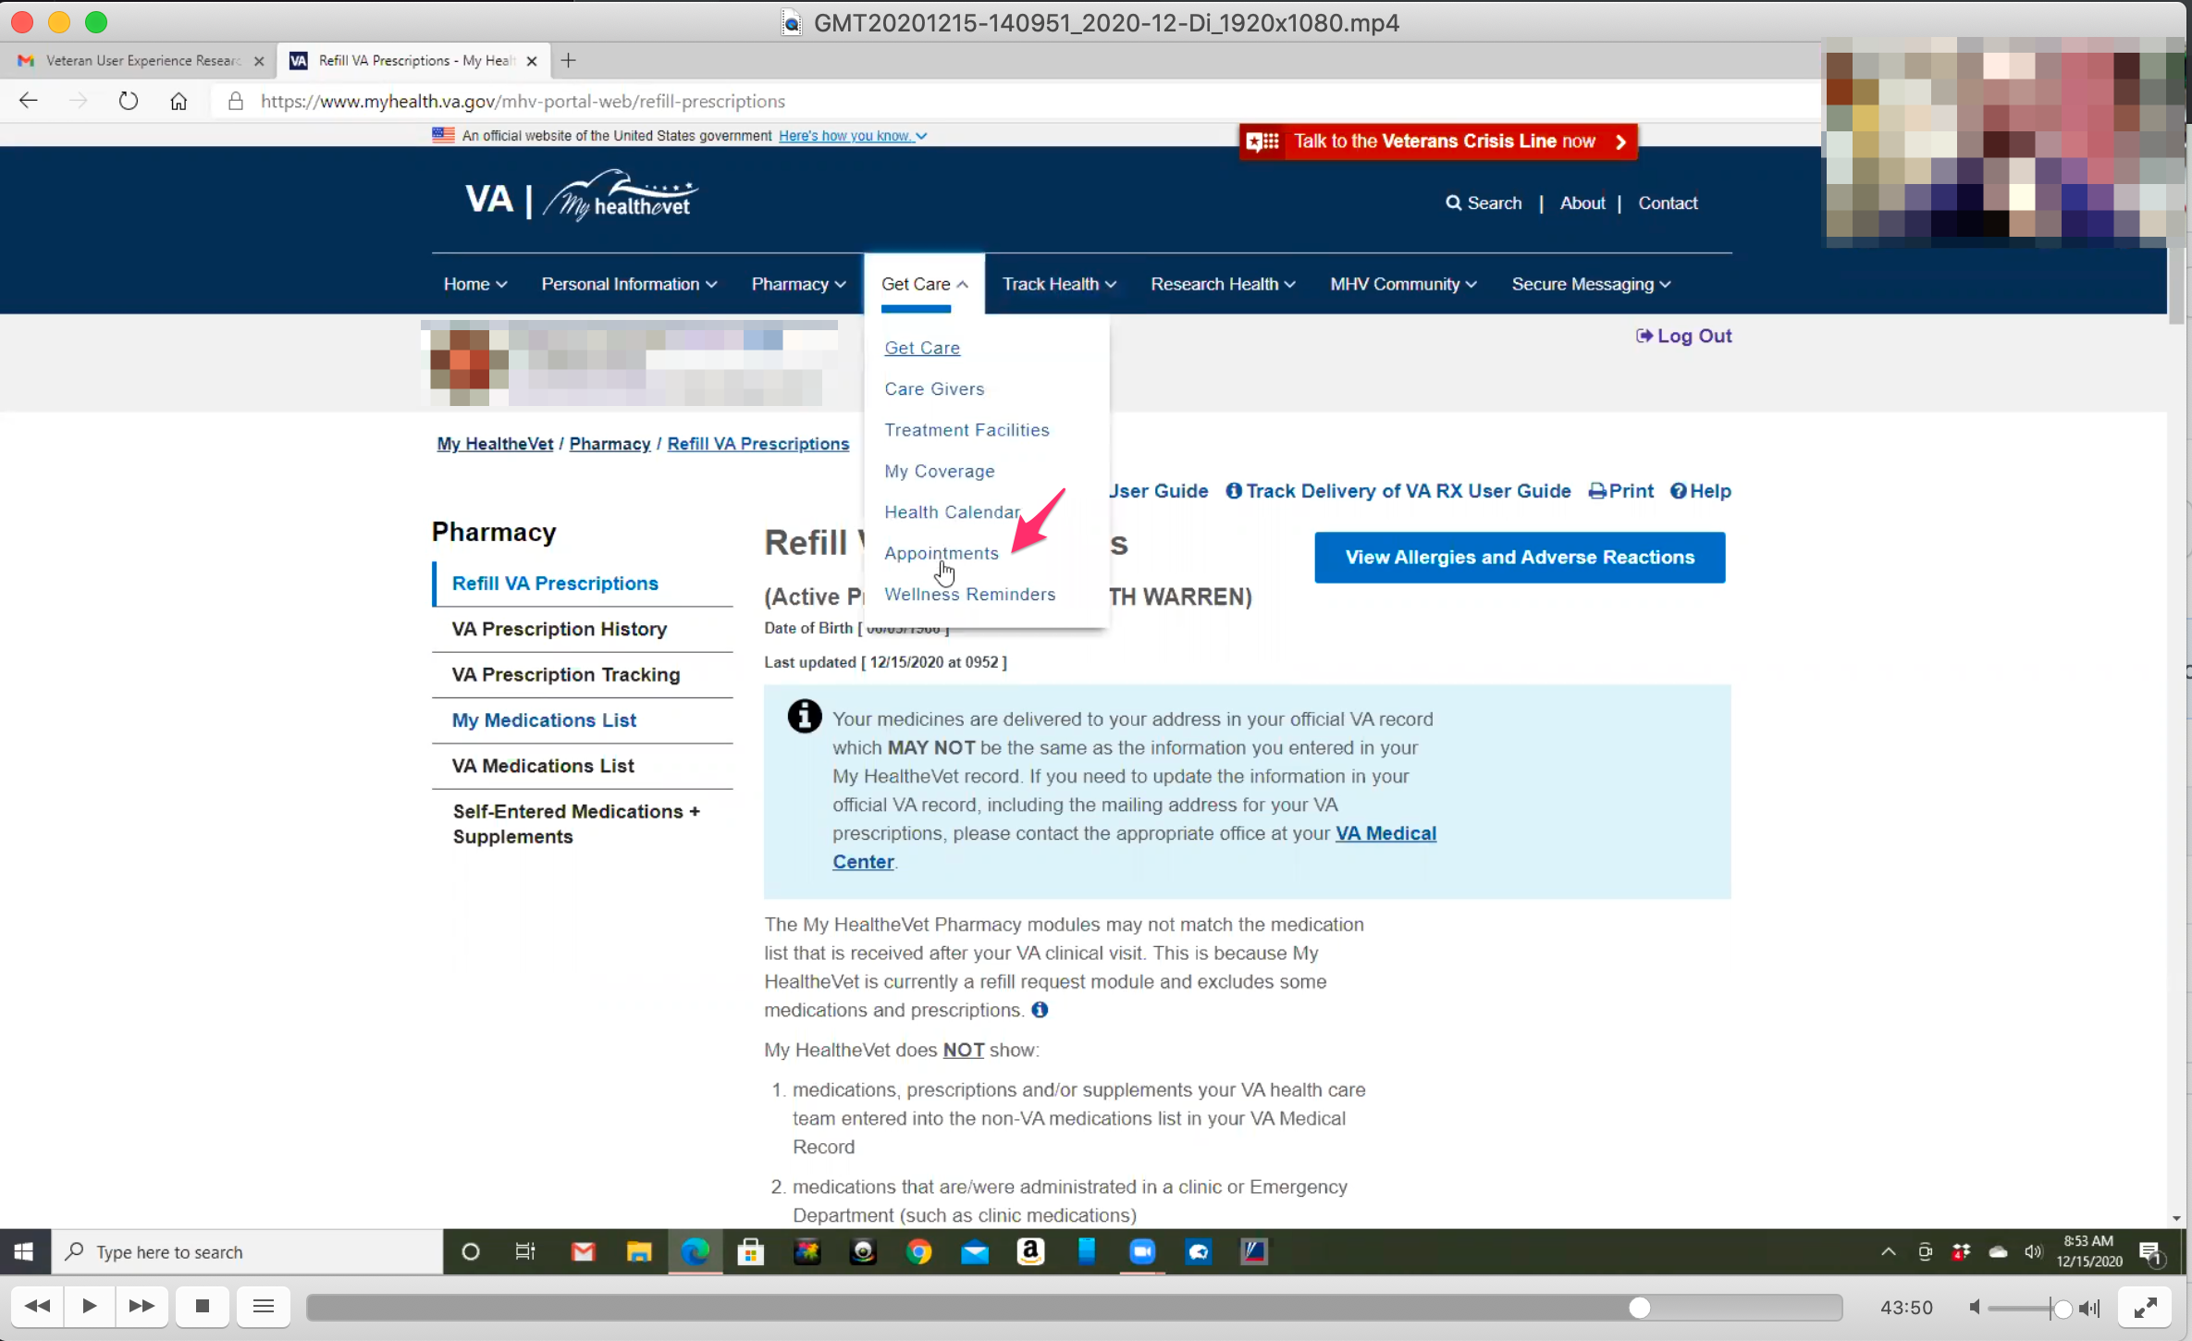

*Participant finds “Appointments” link in main navigation Get Care sub menu dropdown quickly.*

SoI would go to Get Care and click on Appointments and it would come up with my schedule. *Participant clicks on “Appointments” link in main navigation Get Care submenu dropdown.*

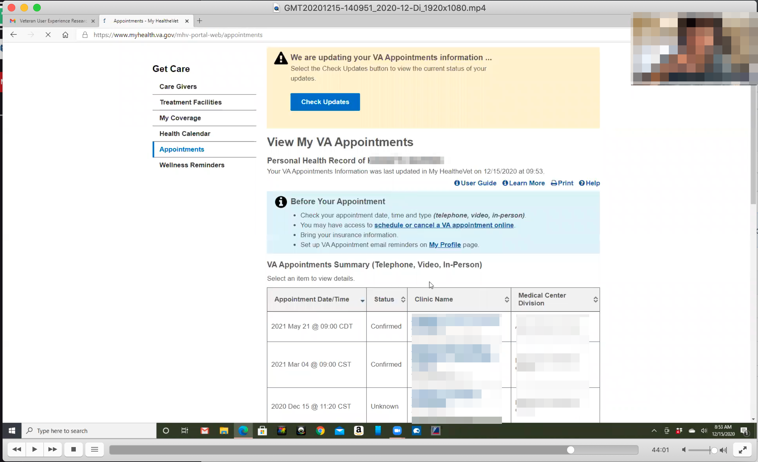

*Participant shows View VA Appointments page.*

*Note: there was no noticeable layout shift on main content load on this page.*

Sometimes it does and sometimes it doesn’t. *Participant is referring to whether or not appointment information is up to date.*

Sometime they’re not always all there. Like today is here so that’s good.

* **You sometimes call to make appointments. Is that your primary method:**

No, that would only be if I am not getting a response on here [My HealtheVet].

I cannot expect to call and actually talk to someone. I might talk to a receptionist, and they are just going to take a message. Very rarely I will call.

I have had a few phone appointments because they don’t want you coming in with this COVID crap. But those were scheduled of course.

I wouldn’t just cold call because I would only talk to a receptionist probably or maybe a nurse. And that would just be the same result as here.

This is my best means of communication with my doctor.

If they don’t always response in a timely manner, it is sometimes but normally she is really good. There were a few times I was obviously not the priority but I get that. I am not naive enough to think I am that damned important.

**Branding and trust (5 minutes)**

Now I’d like to ask for your thoughts on My HealtheVet. (Confirm that participant has used My HealtheVet previously. If not, amend questions below to capture their first impressions while looking at a logged in account.)

1. **On a scale from 1-5, with 1 being very dissatisfied, and 5 being very satisfied, how satisfied are you with My HealtheVet:**

Somewhere in the 4 plus range.

**1.a. What makes you rate it a 4?**

It is a good tool. I can take care of most things I need. Just about everything I need to that is important.

It is pretty handy and they are fairly responsive.

It’s not a phone call. But as I said it doesn’t make sense to make a call if you can’t talk to the person to get an answer. So if this is how to get a response in a timely manner this is great.

Between secure messaging an pharmacy stuff this is what I use it for.

1. **On a scale from 1-5, with 1 being very low, and 5 being very high, how would you rate your trust in My HealtheVet?**

I never though about putting trust in it. Do you mean my trust in response, or the security of the site?

**Both I would be interested to know.**

I have never had a question about security so good in that aspects. I would give it a high 3 low 4 range.

**In terms of responsiveness:**

Probably 3.5, it varies. Sometimes they are really good and other times not so much. To be fair I would give them a high 3, a 3.8 or something like that.

**My HealtheVet patient portal (15 minutes)**

Let's take a look at My HealtheVet together.

Moderator will ask participant to share screen if not already, or show logged in My HealtheVet account. **(5 minutes)**

1. **What do you find the most valuable on this website?**

The thing I use the most is secure messaging; it would be a toss up between secure message and pharmacy stuff.

But I usually take care of some of the pharmacy stuff through secure messaging.

If I had to pick one it would be secure messaging.

**Thank you and closing (2 minutes)**

Feedback: *Participant asked who were the observers on the call. Everyone introduced themselves and thanked the participant for their valuable feedback.*